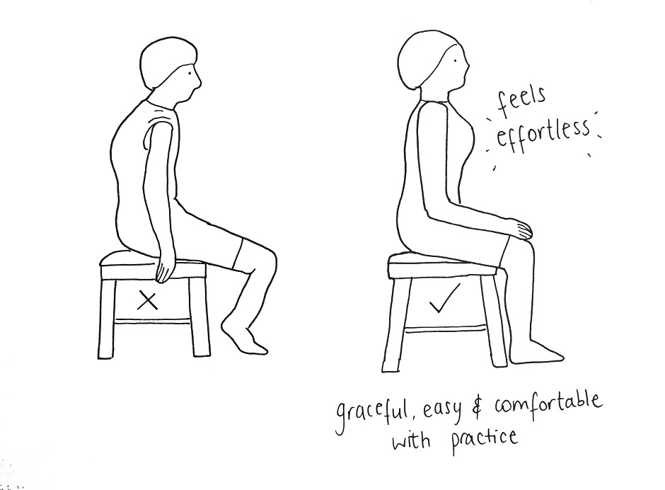
Posture Pointers
Some of us seem to be spending more time at a desk in front of a computer or perhaps bent over using our cell phones for texting or other social media. Our posture may also be compromised when we are driving. Here are a few posture pointers to consider:
- Everything we do is pretty much in front of us causing us to lean forward and if we are not careful, we slump and cave forward. Try to get up to stretch the chest and to lean backwards to stretch your back.
- You are more likely to sit at your desk more that you sleep. You have probably invested in a good mattress so why not do the same for a desk chair? Check the height of your desk chair and the angle of your arms so that you are not driving your shoulders into your ears.
- Do not cross your legs while sitting. This causes one hip to be elevated which can cause a leg discrepancy.
- We all need a posture analysis. Do you drive leaned to the right? Do you carry a heavy bag on one shoulder every day?
- Put your feet up on something under your work space to change your foot position and hip angle. This lets your hamstrings and calves open up.
- Some of the best stretches to do periodically are T’s and Y’s with your arms to open up the chest and shoulders.
- Use an external computer monitor instead of looking down at a laptop screen or phone for lengthy work or reading.
- Don’t wait until you are in pain and can’t function to get help. Find a massage therapist that is the right fit for you to take care of your muscle tension and needs. Do you need a touchy, feely massage or a deeper tissue therapeutic massage? Whichever type of massage that you choose, it is important to hydrate before and after. All of the toxins and junk moved around in your body needs to be cleaned out.

